Evaluating the Effects of FES on BCI Classification Accuracy and Latency During Motor Imagery
Aditya S. Pulipaka, BSECE, UT Austin, Kailasadatta Boggaram, BSECE + BSNeuroscience, UT Austin, Sean Omodon, BSBME, UT Austin, Leelai Teshome, BSECE, UT Austin

Abstract—Brain-computer interface (BCI) accuracy for motor imagery (MI) tasks is a core area needing optimization in today’s search for effective limb prosthesis. In this work, we hope to shed light on the exact relationship between functional electrical stimulation (FES) and overall BCI effectiveness in classifying MI versus REST. Based on existing literature in the field, which explores overall classification performance using FES as opposed to not using FES while keeping the setup the exact same for calibration and subsequent online trials, we hypothesized that BCI MI discriminability is improved when using FES during online trials, regardless of whether it was applied during offline calibration. We based this claim in the reasoning that FES, acting as an amplifier in a feedback loop between the limb, sensorimotor cortex, BCI, and computer, would increase SNR in all trials it was used, making calibration more accurate and online runs more successful. To briefly explain the experimental setup, our data comes from four subjects who each performed two sessions on separate days. The first session consisted of an FES calibration run, followed by FES then NoFES online classification. The second session saw calibration performed without FES, followed by NoFES then FES online classification. Classification was performed using Riemannian generic recentering with a common spatial pattern classifier. Our results show that, although neither MI nor REST accuracy show a consistent trend between FES and NoFES trials across both calibration sessions, there is a significant increase in late-run accuracy in online FES runs when calibrated on NoFES as opposed to calibration on FES. There is also a statistically significant decrease in successful REST classification latency and a nearly statistically significant increase in successful MI classification latency across all online FES trials compared to NoFES trials, with a greater number of subjects likely needed to fully establish significance for both cases. Our findings allow us to conclude that the calibration method does indeed play a significant role in BCI performance with FES – calibration without FES yields higher sustained accuracy during online runs.

Index Terms—electroencephalogram (EEG), motor imagery, brain-computer interface (BCI), functional electrical stimulation (FES), motor function rehabilitation, machine learning, classification accuracy, sensorimotor cortex, feedback loop

This work was supported by Dr. José del R. Millán, Arman Paydarfar, and the CNBI Lab.
Aditya S. Pulipaka is with the Department of Electrical and Computer Engineering, The University of Texas at Austin, Austin, TX 78712 USA (e-mail: adipu@utexas.edu).
Kailasadatta Boggaram is with the Department of Electrical and Computer Engineering, The University of Texas at Austin, Austin, TX 78712 USA (e-mail: kb46242@eid.utexas.edu).
Leelai Teshome is with the Department of Electrical and Computer Engineering, The University of Texas at Austin, Austin, TX 78712 USA (e-mail: leelaiteshome@utexas.edu).
Sean Omodon is with the Department of Biomedical Engineering, The University of Texas at Austin, Austin, TX 78712 USA (e-mail: seanomodon@utexas.edu).

I. Introduction
Noninvasive brain–computer interfaces (BCIs) based on electroencephalography (EEG) have become a primary modality for motor neurorehabilitation following stroke [1] or spinal cord injury [7]. Motor imagery (MI)— mental rehearsal of a movement without overt execution—elicits event-related desynchronization (ERD) in the mu (8–13 Hz) and beta (13–30 Hz) sensorimotor rhythms [3] that can be decoded online to drive assistive devices. Closed-loop MI-BCI training, in which successful MI imagination triggers physical feedback via a robotic orthosis, has been shown to promote lasting cortical reorganization and motor recovery [2].
Functional electrical stimulation (FES) delivers biphasic electrical pulses over peripheral nerves to activate sensory and motor axons. When paired with voluntary effort, FES augments afferent proprioceptive and tactile feedback, and has independently shown benefit for post-stroke upper-limb recovery [2]. A key motivation for combining FES with MI-BCI is the hypothesis that peripheral somatosensory input during MI amplifies the associated cortical ERD, producing a stronger, more discriminable neural signal for the decoder. Yakovlev et al. found that FES delivered concurrently with MI produced significantly stronger mu-rhythm suppression compared with MI alone, supporting this amplification account [4]. If FES consistently enhances ERD magnitude, it could improve BCI decoder accuracy and reduce the calibration burden on users—a persistent challenge in the field.
Despite this extensive existing work, whether the improvement seen in MI-BCI performance when FES is used is independent of which condition the decoder was calibrated on remains an open question. Due to FES’s role in closing the feedback loop between BCI activation, peripheral nerves, and the sensorimotor cortex, it stands to reason that FES would increase class separation regardless of the calibration scheme. This is because in the scenario with NoFES calibration, the ERD magnitude separation between rest and MI would be equal to that needed for successful NoFES online classification, and successful FES online classification will produce a greater separation, meaning FES would thereby increase class discriminability. Meanwhile, calibration on FES would simply increase the ERD magnitude separation for MI detection (if it is indeed simply an amplifier), meaning FES-online would still perform better than NoFES-online, considering it would be the only run capable of exceeding the MI ERD magnitude separation when calibrated using FES.
We therefore hypothesized that BCI MI discriminability is improved when using FES during online trials, regardless of whether it was used during offline calibration.

II. Methods

A. Participants
Four healthy volunteers (ages 19–21 years) participated in the study. All had normal or corrected-to-normal vision and reported no neurological or musculoskeletal conditions affecting the right upper limb.

B. Experimental Protocol
Each participant completed two sessions on separate days. Day 1 began with a calibration run conducted with sensory-threshold functional electrical stimulation (st-FES) enabled (FES_CALIB), which activated after each MI calibration period in tandem with orthotic glove closure, and stayed active until orthotic glove opening (5 seconds after start of close). Day 2 began with a calibration run conducted without FES (NOFES_CALIB). Each calibration run was followed by two online runs—one with FES enabled (ONLINE_FES), which meant st-FES activation as soon as any magnitude of MI classification was recorded and motor threshold FES (m-FES) accompanied with orthotic glove closure once a magnitude significant enough for confirmation of MI was achieved, and one without (ONLINE_NOFES)—yielding four online runs per participant. Run order is illustrated in Fig. 2. Note that FES calibration always preceded NoFES calibration; calibration condition is therefore partially confounded with session day, and this limitation is addressed in Section V.
Each calibration run contained 45 right-hand motor imagery (MI) trials and 45 rest trials in pseudo-random order. Each online block contained 30 MI and 30 rest trials. During MI trials, participants performed motor imagery of right-hand grasping; during rest trials, they relaxed without imagined movement. Trial events were annotated in the data stream via software triggers (MI_BEGIN, REST_BEGIN, MI_EARLYSTOP, MI_END, REST_EARLYSTOP, REST_END, where [Class]_EARLYSTOP signifies successful online classification, ending the trial early, and [Class]_END signifies timeout before successful online classification, or the end of a collection period during calibration sessions).

C. Apparatus
EEG was recorded from the AntNeuro 32 channel wave guard cap at 512 Hz using the MyLab amplifier. A wearable pneumatic orthotic glove (Manufacturer: MZU, Device Model: 8th Generation Hand Rehabilitation Robotic Glove) provided proprioceptive feedback by closing on successful MI detection. When enabled for a run, a two-channel surface FES unit (Device Model: RehMove, Manufacturer: Hasomed) was placed over the right forearm to deliver pulses at sensory threshold (st-FES) during MI cue intervals and at motor threshold (m-FES) during glove-closure events.

D. Online BCI Decoder
The online decoder was implemented using the Generic Recentering (GR) inter-subject transfer learning framework of Kumar et al. [5]. EEG covariances on 1-s sliding windows were transformed onto a common Riemannian manifold via incremental affine recentering and classified by a minimum-distance-to-mean (MDM) classifier trained on the same-day calibration data. Posterior probabilities were accumulated by exponential smoothing; an EARLYSTOP marker was issued when accumulated MI or REST probability exceeded a per-session threshold determined by calibration. On EARLYSTOP, the orthotic glove closed and—during ONLINE_FES blocks—m-FES was delivered. This decoder was not built by us, but rather part of the experimental setup provided by the CNBI Lab.

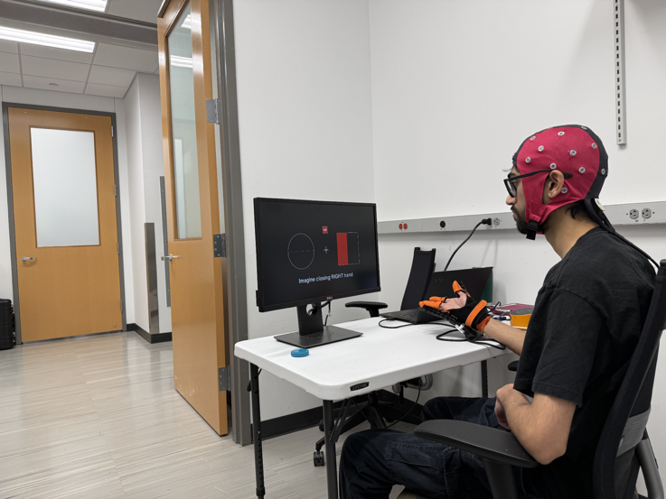
Fig. 1. Participant wearing 32-ch EEG cap with orthotic glove and FES, performing Online MI task.
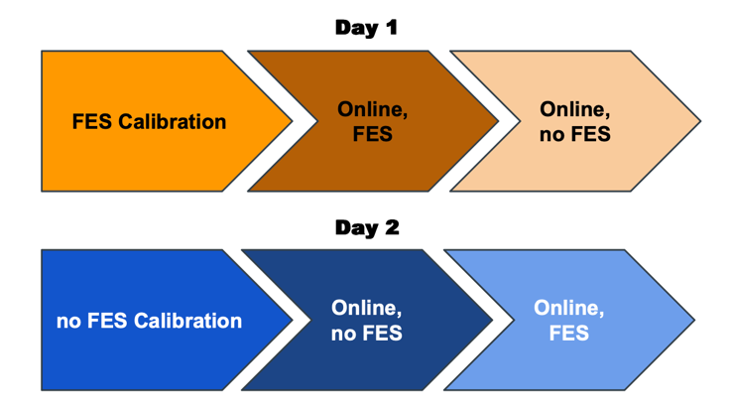
Fig. 2. Experimental protocol. Day 1: FES calibration followed by FES-online and NoFES-online blocks. Day 2: NoFES calibration followed by the same online pair. Colored blocks indicate session type.

E. Offline Signal Analysis Pipeline
1) Preprocessing: The offline preprocessing pipeline is summarized in Table I. Steps were applied in sequence using zero-phase filtering to avoid phase distortion.

2) ERD Computation: Event-related desynchronization (ERD) was computed separately for the mu (8–12 Hz) and beta (18–25 Hz) frequency bands using a standard band-power normalization approach. For each trial, the continuous EEG signal was bandpass filtered using a zero-phase 4th-order Butterworth filter, then instantaneous power was estimated by squaring the filtered signal. ERD was expressed as the percent change in band power relative to a pre-cue baseline window (−1.0 to 0.0 s), using the formula:
$$ERD\left(\%\right)=\left(\frac{P_{task}- P_{base}}{P_{base}}\right)× 100$$
where P_task and P_base denote mean power in the analysis and baseline windows, respectively. The analysis window spanned 1.0 to 4.5 s post-cue onset to capture the sustained MI period while avoiding cue-onset transients. Negative values indicate desynchronization (true ERD), while positive values indicate synchronization (ERS). ERD values were averaged across a contralateral sensorimotor cluster (C3, CP3, C1, CP1, FC3, FC1) to improve signal-to-noise ratio over single-channel estimates.
TABLE I
Offline EEG Preprocessing Pipeline

Stage | Parameters | Purpose
Notch | iirnotch, f₀ = 60 Hz, Q = 30, zero-phase filtfilt | Powerline removal
CAR | Cross-channel mean subtracted per sample | Spatial de-mixing; boost local signal
Bandpass | Butterworth order 4, 8–30 Hz, zero-phase filtfilt | Isolate μ (8–13) + β (13–30) rhythms
Baseline | Mean of [−1, 0] s pre-cue subtracted from epoch | Remove per-trial DC / slow drift
Artifact reject | Per-epoch max peak-to-peak < 100 µV across all channels | Blinks, EMG, electrode pops
3) The Riemannian distance was measured between class manifolds of calibration and online data for each day (FES_CALIB-FES_ONLINE and NOFES_CALIB-NOFES_ONLINE) to test non-stationarity in the case of FES versus NOFES, considering the possibility of stronger mind-body associations when FES was employed.

F. Performance Metrics
Two complementary metric families were computed: Marker-based metrics, derived from EARLYSTOP and END markers issued by the live decoder, characterize the participant's real-time experience: (i) class-specific accuracy, defined as the fraction of cued trials with a correct EARLYSTOP within the timeout (the alternative being END), and (ii) EARLYSTOP latency, defined as the elapsed time from cue onset to correct EARLYSTOP, averaged over successful trials.
Event-related desynchronization (ERD) was computed across the cluster mentioned in II-E(2) in the mu and beta bands as the percent change in band power during MI relative to baseline, with negative values indicating desynchronization.

G. Statistical Analysis
The unit of analysis was the (subject × calibration day) pair, yielding 8 paired observations across 4 participants. For each metric, paired differences (FES − NoFES) were summarized by their mean and 95% bootstrap confidence interval (10,000 resamples of the paired-difference distribution). Confidence intervals excluding zero were treated as evidence of an effect; given the small sample, we additionally report sign counts (number of pairs with FES > NoFES) and avoid reliance on parametric null-hypothesis significance tests. Sliding-window classification accuracy was computed with a window of 8 trials and aggregated across subjects with ±1 SEM bands.

III. Results

A. Data Quality
Across all 24 sessions, each epoch corresponded to a single cued trial (MI or REST). A total of 184 of 1,680 attempted epochs (10.95%) were rejected due to peak-to-peak amplitude exceeding 100 µV across any channel. Subject 009 showed markedly elevated artifact rates: 33 of 90 offline FES calibration trials (36.7%) contained artifacts, and on the same FES-calibration day, 59 of 60 ONLINE_NOFES epochs (98.3%) contained artifacts, yielding a single valid epoch for that session. Subject 003's ONLINE_NOFES session under FES calibration yielded only 38 valid epochs before preprocessing compared to the expected 60, reflecting an incomplete recording. All sessions are retained in marker-based analyses, which operate on trigger timestamps and do not depend on EEG epoch quality. Marker-based accuracy and latency metrics derive solely from the timing of EARLYSTOP and END triggers logged by the decoder, which are independent of EEG signal quality; the high artifact rate in Subject 009 therefore, does not compromise the validity of these behavioral measures.

B. Classification Accuracy
Per-subject and aggregate accuracy results are shown in Fig. 3 and Table II, respectively. Overall marker-based accuracy was high across all conditions (range: 0.717–0.933). Averaging across 8 (subject × calibration day) pairs, FES and NoFES online accuracy were nearly identical: FES 0.821 ± 0.077 vs. NoFES 0.806 ± 0.075 (paired Δ = +0.015, 95% CI [−0.040, +0.065]; 4/7 pairs FES > NoFES). Neither MI accuracy nor REST accuracy showed a CI excluding zero (MI: Δ = +0.042, CI [−0.079, +0.142]; REST: Δ = −0.012, CI [−0.070, +0.039]). No consistent direction of FES benefit was observed across subjects when data were split by calibration type (Fig. 3).
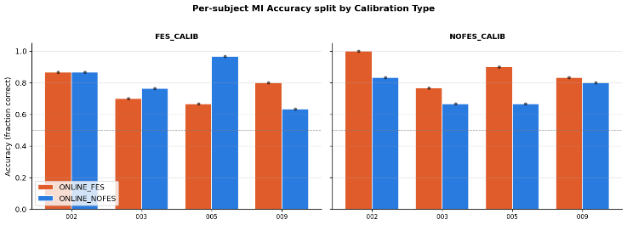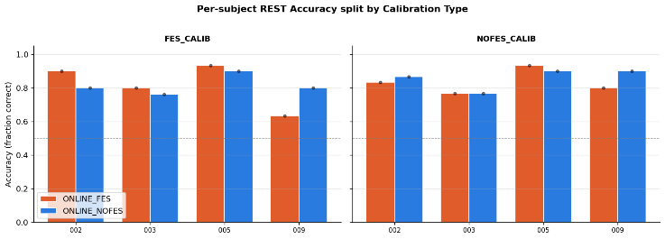
Fig. 3. Per-subject MI (top) and REST (bottom) classification accuracy split by calibration type (FES_CALIB vs. NOFES_CALIB). Orange: ONLINE_FES; Blue: ONLINE_NOFES. No consistent FES advantage is observed across subjects or calibration conditions.

C. EARLYSTOP Latency
Despite equivalent accuracy, FES produced a statistically reliable effect on detection latency (Fig. 4). MI detection latency was significantly higher under FES (2.523 ± 0.204 s) compared with NoFES (2.235 ± 0.209 s), a mean paired increase of +288 ms (95% CI [+0.058, +0.530]; 6/8 pairs). Conversely, REST detection latency was significantly lower under FES (2.135 ± 0.303 s) compared with NoFES (2. 391 ± 0.270 s), a mean paired decrease of −256 ms (95% CI [−0.416, −0.077]; 2/8 pairs FES > NoFES, i.e., 6/8 showed FES faster). These opposing latency shifts were present across both calibration-day conditions and represent the first conclusive finding of our analysis.
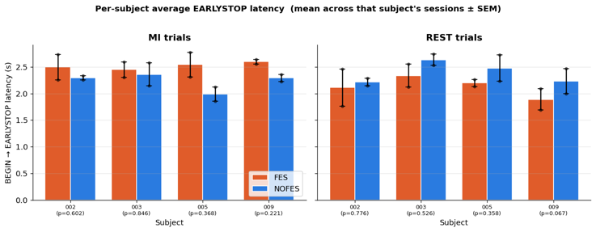 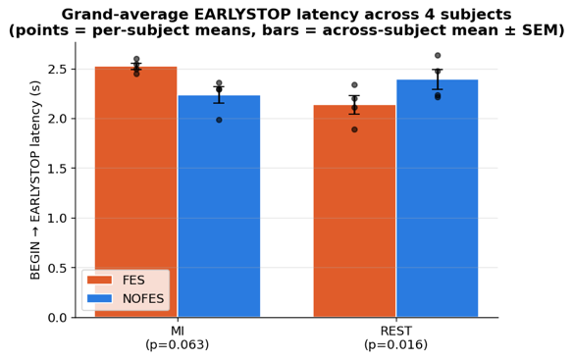
Fig. 4. EARLYSTOP latency. (Top) Per-subject average latency (mean ± SEM) for MI and REST trials. (Bottom) Grand average across 4 subjects. MI latency is significantly longer under FES; REST latency is significantly shorter (95% bootstrap CI excludes zero for both). p-values from paired t-test shown for reference.
D. Within-Session Accuracy Trajectory
To assess whether FES conditions differed in sustained performance across trials within a session, a sliding-window accuracy analysis was applied using a window of 8 consecutive trials, averaged across subjects with ±1 SEM bands (Fig. 5). When the FES-online sessions were analyzed, NoFES-CALIB runs showed noticeably higher and more sustained accuracy trajectories for MI trials than FES-CALIB runs, particularly across trials 5–20. This pattern was absent with NoFES-online runs, where accuracy trajectories for the two calibration conditions were more interleaved and inconsistent. For REST trials, no clear separation between FES and NoFES online conditions was evident under either calibration type, though FES-online trials showed slightly higher peak performance and sustained accuracy with NoFES-CALIB than with FES-CALIB, similar to the MI trials. These trajectory results provide a deeper, more granular view into the data deemed inconclusive in section III-B and comprise the second conclusive finding of our analysis.
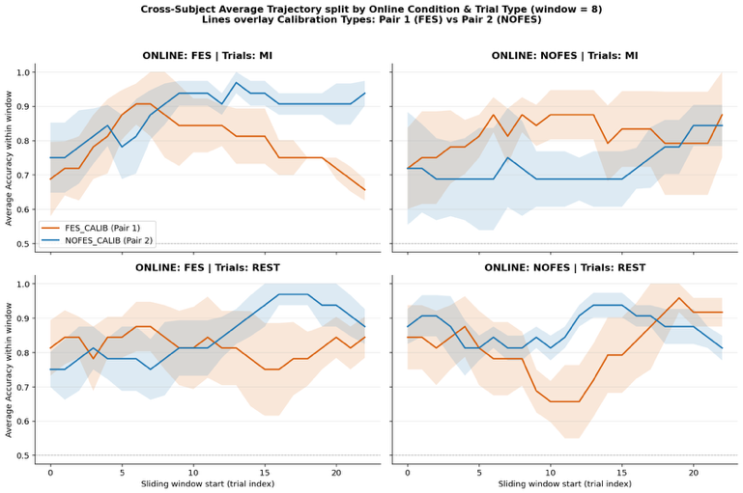
Fig. 5. Cross-subject sliding-window classification accuracy (window = 8 trials, ±1 SEM shading) split by online condition and trial type. Orange: FES_CALIB; Blue: NOFES_CALIB. The clearest pattern emerges in the ONLINE_FES × MI panel: NOFES_CALIB begins lower but rises across the session, overtaking FES_CALIB and sustaining higher accuracy through the run.
F. ERD Analysis
ERD patterns at contralateral sensorimotor channels were highly variable across subjects (Fig. 6, Fig. 7). For subject 005, FES was associated with negative mu-band ERD during MI (−18%), consistent with expected cortical desynchronization, while NoFES showed positive power change (+20%), suggesting ERD was only present under FES for this subject. In contrast, subjects 002 and 003 showed broadly similar positive mu-band magnitudes, implying ERS, under both conditions. Subject 009 showed anomalous negative ERD under both conditions, likely reflecting the high artifact presence in that participant's data. No consistent cross-subject direction of FES effect on ERD was identified in either the mu or beta band.

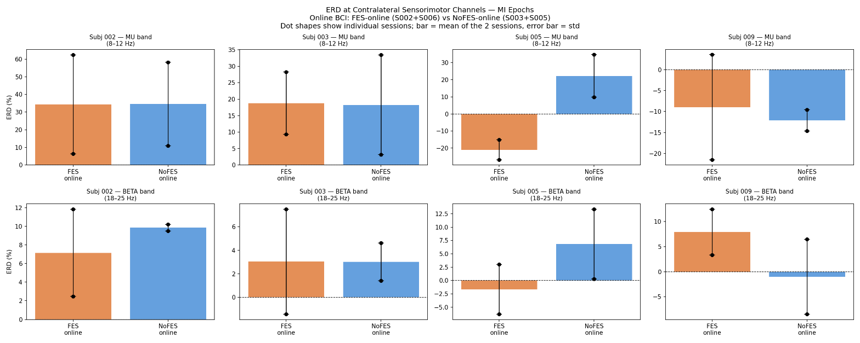

Fig. 6. ERD magnitude (%) across all subjects in the mu (8–12 Hz) and beta (18–25 Hz) bands during MI trials, comparing FES-online (orange, sessions S002 and S006) versus NoFES-online (blue, sessions S003 and S005). Bars represent the mean of the two pooled sessions; error bars show standard deviation; black dots indicate individual session values. Negative values indicate desynchronization.

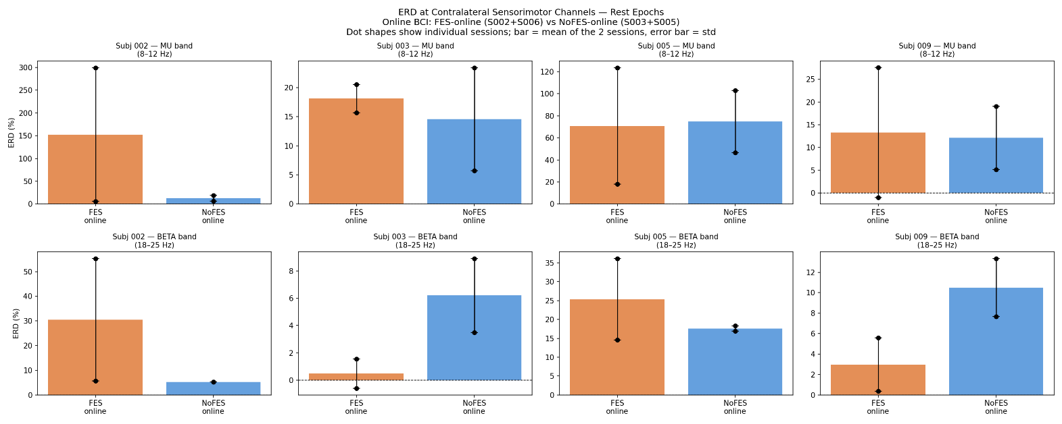

‘

Fig. 7. ERD magnitude (%) across all subjects in the mu (8–12 Hz) and beta (18–25 Hz) bands during REST trials, comparing FES-online (orange, sessions S002 and S006) versus NoFES-online (blue, sessions S003 and S005). Bars represent the mean of the two pooled sessions; error bars show standard deviation; black dots indicate individual session values. Negative values indicate desynchronization.

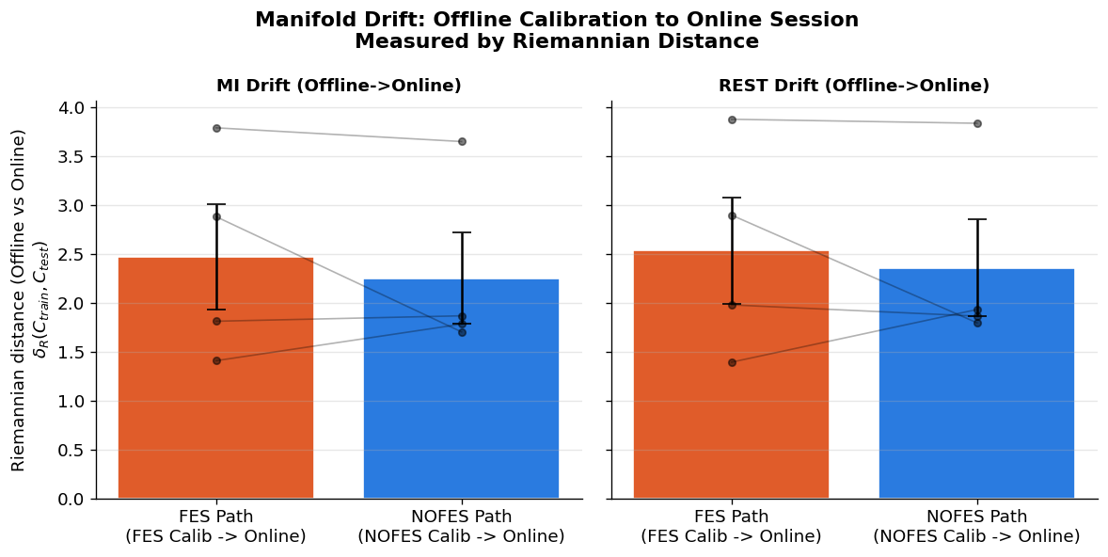
Fig. 8. Covariate shift between offline and online sessions measured via Riemannian distance (δ_{R} ) for MI and REST class manifolds, comparing FES and NoFES. Higher values indicate greater non-stationarity, from the initial calibration distribution to the testing phase. Results are paired per-subject.

G. Riemannian Distance analysis
Signal drift was compared between FES-CALIB to FES-Online and NOFES-CALIB to NOFES-Online, to gauge potential effects of FES on non-stationarity. No significant effect was found, and each subject seemingly had different trends as shown by the 4 lines on each graph in Fig. 8. This null result suggests the covariate shift observed in both FES and NoFES conditions is driven by individual factors rather than stimulation-induced signal drift.

TABLE II
Aggregate FES vs. NoFES Performance (N = 8 subject × calibration-day pairs; *CI excludes zero)
Metric | FES (mean ± SD) | NoFES (mean ± SD) | Paired  Δ(FES−NoFES) | 95% Bootstrap CI
Overall accuracy | 0.821 ± 0.077 | 0.806 ± 0.075 | +0.015 | [−0.040, +0.065]
MI accuracy | 0.817 ± 0.108 | 0.775 ± 0.115 | +0.042 | [−0.079, +0.142]
REST accuracy | 0.825 ± 0.100 | 0.837 ± 0.061 | −0.012 | [−0.070, +0.039]
MI EARLYSTOP latency (s)* | 2.523 ± 0.204 | 2.235 ± 0.209 | +0.288 | [+0.058, +0.530]
REST EARLYSTOP latency (s)* | 2.135 ± 0.303 | 2.391 ± 0.270 | −0.256 | [−0.416, −0.077]

IV. Discussion
Our central hypothesis—that FES would improve MI discriminability regardless of calibration condition—was not supported. Run-wise classification accuracy was statistically equivalent across FES and NoFES online conditions under both calibration regimes, likely due to low subject count (four subjects is barely enough to make any significant claims at all). This null result is, however, accompanied by a clear, informative pattern in detection latency: FES slowed MI detection and accelerated REST detection, opposing effects that each reached bootstrap significance across eight paired comparisons. Latency was seen as a key factor in BCI performance due to its role in giving users a sense of agency – lower latency signifies a more effective BCI, since it makes actions feel ‘real-time.’
We take this latency discrepancy to be evidence that FES during detected MI creates a stronger neural relaxation effect when MI is not occurring. Rather than amplifying the class separation, we believe that FES enables a quicker and more stable return to REST, whether due to the subject’s increased desire to avoid venturing into the MI range (lest they activate the FES and trigger a positive feedback spiral) or due to sensorimotor cortex fatigue due to increased activity during FES (though this is less supported when the mixed ERD results from section III-F are taken into account). The first interpretation is consistent with the absence of a FES advantage in offline EEG metrics: if FES amplified the separation between MI and FES features, we would expect higher observed MI ERD with FES than without, since this is the main feature associated with classification of MI. This was not observed.
These findings appear to contradict Yakovlev et al. [4], who reported enhanced mu-rhythm ERD with FES during MI. Several methodological differences may account for this discrepancy. Yakovlev et al. assessed ERD offline in a passive recording paradigm, whereas our participants operated a closed-loop BCI during which they may have adapted their neural strategy in ways that partially counteract FES-driven ERD. Additionally, our st-FES intensity was calibrated to remain below the motor threshold, delivering a lighter afferent input than the stimulation parameters reported by Yakovlev et al. ERD results in our dataset were highly variable across subjects, with no consistent direction—a finding consistent with the known inter-individual variability in FES sensitivity and MI ability [5]. Individual fatigue from the FES device may also be a confounding variable in this scenario, which also sheds light on a possible reason for the failure of multiple subjects to sustain classification accuracy when performing FES-Online MI after FES-CALIB as opposed to after NoFES-CALIB.
The second clear pattern shown was the calibration-condition dependency observed during within-run sliding-window accuracy analysis of MI, FES-Online trials (Fig. 5, top-left panel). This is suggestive of an FES “sweet spot”, where FES applied for a short period may improve accuracy, but if continuously applied, begins to tamper with classification reliability due to subject fatigue or FES-induced within-run signal drift. Alternative explanations, such as FES amplifying ERD and causing an existing NoFES-calibrated classifier to more clearly detect MI with FES, don’t fit the results of our ERD analysis in III-F or our overall accuracy analysis in III-B.

Limitations
Several limitations exist. First, the fixed ordering of FES calibration on Day 1 and NoFES calibration on Day 2 confounds calibration condition with session day, fatigue, and within-subject learning effects; a fully counterbalanced design would be necessary to separate these factors. Second, the cohort of four participants provides limited statistical power; while bootstrap CIs for the latency metrics exclude zero, replication in a larger sample is required before strong causal claims can be made. Third, no FES artifact rejection step was applied beyond the broadband PTP threshold; FES-induced electrical transients in the EEG, if present, could have degraded MI-trial quality when FES was applied. Fifth, as noted during our presentation, the visual cue of MI/REST appeared abruptly and is assumed to coincide perfectly with the MI_BEGIN or REST_BEGIN marker, which could cause confounding signals from Visual Evoked Potentials. Finally, runs without the orthotic glove were not included, preventing isolation of FES effects from glove-related proprioceptive feedback.

V. Conclusion
We examined whether FES enhances online MI-BCI performance in a closed-loop setting with an assistive hand orthotic device. Contrary to our hypothesis, FES did not improve overall classification accuracy relative to NoFES under either calibration condition, though we acknowledge this may be a result of low statistical power or other confounding variables as listed above. The primary finding was a class-specific latency dissociation: FES significantly prolonged MI detection delay (+288 ms) while significantly accelerating REST detection (−256 ms), consistent with a user-side shift in intent or stability of thought rather than true MI signal amplification. Offline EEG metrics corroborated this interpretation, showing no FES advantage in signal separability or ERD magnitude. The secondary finding was an apparent FES-induced fatigue when multiple FES sessions were conducted in a day: there was a more steady upward trend and plateau in within-session accuracy for FES-online trials with NoFES calibration than with FES calibration, consistent with anticipated effects of fatigue in the sensorimotor cortex from repeated turbulence caused by the FES feedback. Both of these findings have significant implications for users of FES-enabled rehabilitation devices. A gap of hundreds of milliseconds can make the difference between a feeling of real-time control and a feeling of sluggish, laggy motion when controlling a prosthetic. Similarly, prolonged use of a fatigue-inducing FES-enabled device can certainly cause rejection by the user and undermine the underlying purpose of FES – to help disabled individuals regain agency in their lives. After reflection on the limitations of this study, we propose that future work should employ a counterbalanced multi-day design with larger participant cohorts, dedicated FES artifact rejection, and glove-absent control conditions to isolate the independent contributions of FES and orthotic feedback to BCI performance.

Acknowledgment
A. S. Pulipaka, K. Boggaram, S. Omodon, and L. Teshome thank Prof. Jose Millán and Anastasiia Melnichuk for a wonderful semester and a lively class environment. We also thank Arman Paydarfar and other parties who aided in the collection and distribution of data. We also thank subject 2 (unidentified) for providing us with the statistical power boost needed to surmount invalidated data from other subjects due to artifact rejection.

References
[1] A. Ramos-Murguialday et al., "Brain-machine interface in chronic stroke rehabilitation: a controlled study," Ann. Neurol., vol. 74, no. 1, pp. 100–108, 2013.
[2] A. Biasiucci et al., "Brain-actuated functional electrical stimulation elicits lasting arm motor recovery after stroke," Nat. Commun., vol. 9, no. 1, pp. 1–13, 2018.
[3] G. Pfurtscheller and F. H. Lopes da Silva, "Event-related EEG/MEG synchronization and desynchronization: basic principles," Clin. Neurophysiol., vol. 110, no. 11, pp. 1842–1857, 1999.
[4] L. Yakovlev et al., "Functional electrical stimulation enhances event-related desynchronization during motor imagery," Front. Neurosci., 2023.
[5] S. Kumar, H. Alawieh, F. S. Racz, R. Fakhreddine, and J. del R. Millán, "Transfer learning promotes acquisition of individual BCI skills," PNAS Nexus, vol. 3, no. 2, pp. 1–15, 2024, doi: 10.1093/pnasnexus/pgae076.
[6] B. Blankertz, R. Tomioka, S. Lemm, M. Kawanabe, and K.-R. Müller, "Optimizing spatial filters for robust EEG single-trial analysis," IEEE Signal Process. Mag., vol. 25, no. 1, pp. 41–56, 2008.
[7] G. Pfurtscheller, P. Linortner, R. Winkler, G. Korisek, and G. Müller-Putz, "Discrimination of motor imagery-induced EEG patterns in patients with complete spinal cord injury," Comput. Intell. Neurosci., vol. 2009, Art. no. 104180, 2009, doi: 10.1155/2009/104180.

Statement of Work
Kailasadatta Boggaram (25%): EEG preprocessing pipeline, ERD analysis (with Figs. 6-7), manuscript writing (Methods, Results).
Leelai Teshome (25%): Experimental protocol outlining, data collection coordination, figure preparation (Figs. 3–4), manuscript writing (Introduction, Discussion).
Aditya Pulipaka (25%): Online BCI decoder reconstruction (Riemannian GR framework), latency and accuracy metric computation from markers, sliding-window accuracy analysis, figure preparation, manuscript writing (Results, Conclusion).
Sean Omodon (25%): Gathering of FES and orthotic apparatus specifics, statistical analysis (bootstrap CI framework, T-Tests as additional metrics), manuscript editing and integration.

